Unit C Homework Questions: Circulatory and Immune System:
Lesson 1: The Heart

1. Slide 8 — Main functions of the circulatory system
According to slide 8, what are the three main functions of the circulatory system?

2. Slide 9 — Early theories and William Harvey
Using slide 9, explain:
a. What did early theories suggest about how blood moved in the body?
b. What did William Harvey propose instead?
c. What did Harvey determine about blood volume in the body?

3. Slides 10–11 — Heart anatomy
Using slides 10–11, answer the following:
a. About how large is the heart?
b. What is the pericardium?
c. Name six structures labelled on the heart diagram in slide 11.

4. Slides 14–15 — Major vessels and the pulmonary exception
Using slides 14–15, answer the following:
a. What does the superior vena cava bring to the heart?
b. What does the inferior vena cava bring to the heart?
c. Which vessels bring oxygenated blood from the lungs to the heart?
d. Which vessels send deoxygenated blood from the heart to the lungs?
e. Explain why the pulmonary veins and pulmonary arteries are the exceptions to the usual rule for veins and arteries.

5. Slides 15–16 — Coronary arteries and bypass surgery
Using slides 15–16, answer the following:
a. What is the role of the coronary arteries?
b. What happens if these arteries become blocked?
c. Why is a blockage especially dangerous for the heart?
d. How does coronary bypass surgery help?

6. Diagram Question — Slides 11, 14, 15, and 18
Using your blank heart diagram and slides 11, 14, 15, and 18:
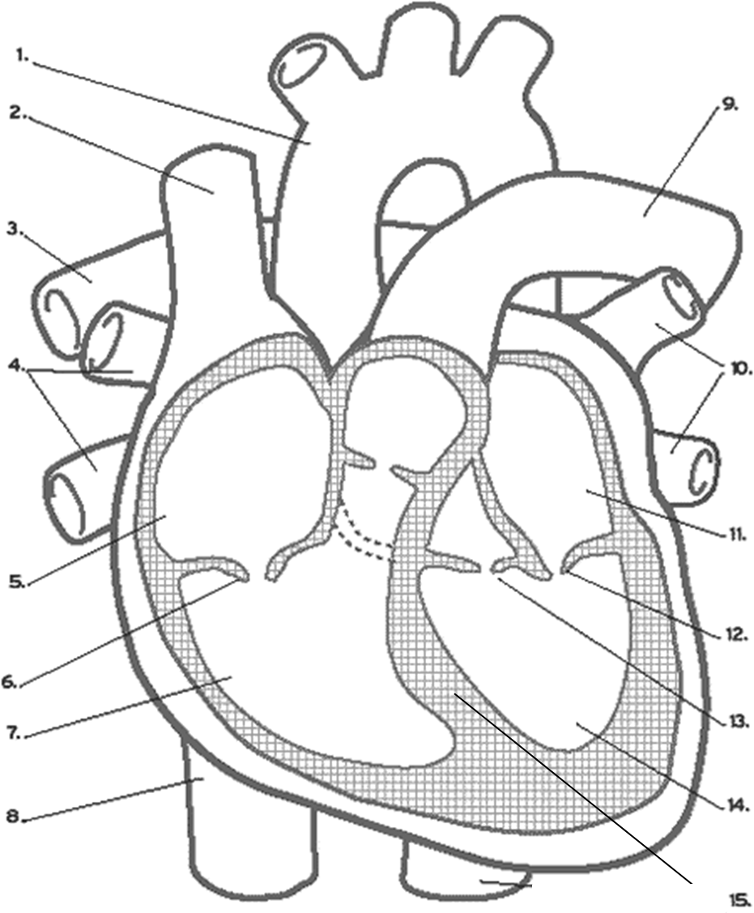

Lesson 2 Homework — Heartbeat and Cardiac Output
Based on slides 20–31

1. Slide 20 — Myogenic muscle
Slide 20 describes the heart muscle as myogenic muscle.
a. What does myogenic mean?
b. How is heart muscle different from many other muscles in the body?

2. Slide 21 — SA node and AV node
Using slide 21, answer the following:
a. What structures set the tempo of the heart?
b. Why are these nodes described as acting like a pacemaker?
c. Why must surgeons be careful not to cut the nerves running from these nodes?

3. Slides 22–23 — ECG
Using slides 22–23, answer the following:
a. What does ECG stand for?
b. What does the P wave represent?
c. What does the QRS wave represent?
d. What does the T wave represent?
e. What might abnormal peaks and lines on an ECG suggest?

4. Slides 25–26 — Heart sounds and murmurs
Using slides 25–26, answer the following:
a. What causes the “lub” sound?
b. What causes the “dub” sound?
c. What is a heart murmur?
d. Why does a murmur create a gurgling or unusual sound?

5. Slides 28–31 — Cardiac output calculations
Using slides 28–31, answer the following:
a. What is cardiac output?
b. What two factors affect cardiac output?
c. Write the formula for cardiac output.
d. Tom’s heart has a stroke volume of 50 mL and a heart rate of 100 beats per minute. What is his cardiac output in mL/min?
e. According to slide 31, what is the cardiac output of an average person?
f. Why do people with lower resting heart rates often have a greater stroke volume?

6. Diagram Question — ECG and Cardiac Output
Draw a simple ECG trace and label the following waves and explain what each wave means:
- P wave
- QRS wave
- T wave

Lesson 3— Blood Vessels and Blood Vessel Disorders

1. Pathway of blood through blood vessels
Describe the path blood takes as it moves away from the heart, through body tissues, and back to the heart.
Your answer should include these terms:
- arteries
- arterioles
- capillaries
- venules
- veins

2. Arterioles and capillaries
Answer the following:
a. What controls the diameter of the arterioles?
b. What is vasoconstriction?
c. What is vasodilation?
d. Why are capillaries only one layer of cells thick?
e. Why do blood cells move through capillaries single-file?

3. Bruising and return of blood to the heart
Answer the following:
a. What happens when capillaries are broken?
b. What is this called?
c. Why is blood in the veins not under high pressure?
d. What two things help move blood back to the heart through the veins?

4. Aneurysm and atherosclerosis
Compare aneurysm and atherosclerosis. In your answer, explain:
- what an aneurysm is
- what atherosclerosis is
- one danger of each condition
- one treatment named in the slides

5. Varicose veins
Explain how varicose veins form.
Your answer should include:
- loss of elasticity
- blood pooling
valve damage
- bulging veins in the extremities

6. Diagram Question
Draw and label a simple diagram showing the three main types of blood vessels:
- artery
- capillary
- vein
Then add short notes beside each one to show:
- direction of blood flow relative to the heart
- pressure level
- wall thickness
- whether valves are present
- one key function
- You may also include arterioles and venules if you want to show the full pathway.

Lesson 4 — Blood Pressure

1. Measuring blood pressure
According to slide 51, what instrument is used to measure blood pressure?
What artery in the arm is used during this measurement?

2. Systolic and diastolic pressure
a. What is systolic blood pressure?
b. What is diastolic blood pressure?
c. At what point in the measurement is each one taken?

3. Highest blood pressure and capillaries
a. Where is the highest blood pressure found in the body?
b. Why is it highest there?
c. What happens to blood pressure as blood enters the capillaries?

4. Regulation of blood pressure
According to slide 54, what two major factors regulate blood pressure?
How can dilation and constriction of the arterioles affect blood pressure?

5. Hypertension
Using slides 54–56, answer the following:
a. What is hypertension?
b. List four risk factors for hypertension from the slides.
c. List two possible health problems that hypertension can lead to.
d. Give two treatments named in the slides.

6. Diagram Question — Systole and Diastole
Draw two simple heart diagrams:
- Heart in systole
- Heart in diastole
For each diagram:
- label whether the ventricles are contracting or relaxing
- show whether blood pressure is higher or lower
- indicate whether this matches systolic pressure or diastolic pressure
Under the diagrams, write 2–3 sentences explaining the difference between systole and diastole.
Lesson 5 - Components of the Blood

Short Answer Questions
- What is plasma, and what percentage of blood volume does it make up?
Include at least three substances found in plasma.

- Describe two structural features of erythrocytes (red blood cells) that help them do their job.
Explain how each feature helps with oxygen transport.

- What are leukocytes, and what is their main function in the blood?

- What are platelets, and what happens when they come into contact with a broken blood vessel wall?

- Explain the main steps of blood clotting in order.
Your answer should include these terms:
thromboplastin, prothrombin, thrombin, fibrinogen, fibrin

Diagram Question
- Draw and label a simple blood sample diagram showing the following four components: (use a blood draw vial as an easy example)
  - Plasma
  - Erythrocytes (red blood cells)
  - Leukocyte (white blood cell)
  - Platelets
  - Under your diagram, write one function for each component.

Lesson 6 - Functions of the Blood
- How does blood help regulate body temperature?
In your answer, include the terms vasoconstriction and vasodilation.

- Why are capillaries important for exchange between the blood and body cells?
Give two reasons based on their structure or function.

- What is interstitial fluid, and why is it important in capillary exchange?

- Explain how diffusion allows materials to move between the blood and the interstitial fluid.
Use oxygen, nutrients, and wastes as examples.

- Compare hemophilia and leukemia.
For each disorder, state:
  - what goes wrong in the blood
  - one major effect on the body

Diagram Question
- Draw a simple diagram to show how blood helps regulate body temperature.
Your diagram should include:
  - skin surface
  - blood vessels near the skin
  - vasodilation
  - vasoconstriction
  - arrows or labels showing more heat loss and less heat loss

Lesson 7 — Immune System / Lymphatic System
- What is the lymphatic system, and how is it connected to the circulatory system?
Include the name of the blood vessels where this connection occurs.

- Explain two important functions of lymph nodes in the immune system.
Your answer should refer to both macrophages and lymphocytes.

- What is the difference between general barriers, non-specific defenses, and specific defenses?
Give two examples of each.

- What is the difference between an antigen and an antibody?
Include how the shape of an antibody is important to its function.

- Why can some viruses be especially difficult for the immune system to deal with?
Include one idea about mutation or hiding in immune cells.

Diagram Question
- Draw and label a chart showing the body’s three levels of defense.
Your chart should include:
  - General Barriers
  - Non-Specific Defenses
  - Specific Defenses
  - Under each heading, include at least two correct examples.

Lesson 8 — Immune System Response
1. Antigen Presentation and Helper T Cells
When a macrophage destroys an invading pathogen, what happens to the pathogen’s antigens, and how do helper T cells become involved?

2. Lymphokine as a Chemical Signal
What is lymphokine, and why is its release important in starting the immune response?

3. Activation of B Cells and Killer T Cells
Describe what happens after helper T cells release lymphokine. Include the roles of B cells and killer T cells.

4. How Killer T Cells Protect the Body
How do killer T cells help protect the body from both virus-infected cells and cancer cells?

5. Shutting Down the Immune Response
After the infection is under control, what roles do suppressor T cells, phagocytes, and memory T cells play?

Diagram Question
6. Diagram: Cell-Mediated Immune Response
Draw a labelled flowchart showing the cell-mediated immune response from pathogen entry to shutdown of the response. Include:
- pathogen
- macrophage
- antigen
- helper T cell
- lymphokine
- B cell
- antibody
- killer T cell
- suppressor T cell
- memory T cell

Lesson 9: Blood Type and Autoimmune Disorder
- Why were early blood transfusions sometimes deadly, and what discovery helped explain the problem?

- What causes the difference between A, B, AB, and O blood types?
Include what is found on the surface of the red blood cells.

- Compare the red blood cells of a person with type A blood, type B blood, type AB blood, and type O blood.

- What is the Rhesus factor, and what is the difference between being Rh+ and Rh−?

- What is an autoimmune disorder, and what happens when the immune system treats self-cells as foreign invaders?
Give one example.

Diagram Question
- Draw and label a chart of blood types and red blood cell markers.
Your diagram should include:
  - type A
  - type B
  - type AB
  - type O
  - the presence or absence of the A and B glycoprotein markers
  - a note showing that the Rh factor is a second antigen that may also be present or absent

